Consumer Intake & Establishing Eligibility

Date Consumer: Birth Date:

Telephone Numbers: and/or County:

Physical Address: Mailing Address:
(Street) (Street)

(City, State, Zip) (City, State, Zip)

E-mail Address: Race: Gender: Male or Female

Marital Status: Registered Voter? YES or NO Veteran? YES or NO

Education Level: Program:

Guardian? YES or NO If Yes, Name:

Telephone Numbers: and/or

SS#: Medicaid: Medicare #

Monthly Income: Do you have a Spenddown? Yes/Amt $_ No Has this Consumer relocated from a Nursing Home Facility back into the community?
If no, has this Consumer continued to live in the community of his/her choice?

** This consumer is eligible / ineligible (circle one) for services from Access II, ILC because of:

Please list the Consumer’s disability(s) below:
Date Began Disability Type Specific Disability

Independent Living Plan
Goal Type Set Date Target Date Completed Description

Sign Here ONLY If I choose to WAIVE my Independent Living Plan:

Alternate Contact Name: Relationship: Address:
Telephone: Alternate Phone:

Establishing Eligibility

Check any that apply
� Currently Employed (16 + hours) Employer:
� Hired to Begin Working Date:
� Seeking Employment
� In School At:
� Live Independently, Not Employed

Check all that apply
� Private Home � Live Alone
� Apartment � Live with Attendant
� Group Home � Live with Spouse and Children
� Nursing Home � Live with Parents and Other Family
� Special Housing � Live with Other Adults

List names and relationships of adult family members who live with you:

Do you plan to change your living situation in the near future? � Yes � No
If Yes, please explain:

Are you currently using Consumer Directed Services (CDS) ? � Yes � No
If yes, please explain:

Are you currently receiving services through Department of Health & Senior Services (DHSS), or have you in the past? � Yes � No

VR Office Mental Health DHSS Other

Staff Signature Date

Consumer/Guardian Signature Date
Demographics / About Our Services

Date: ___ Consumer Name:
DOB: ___ Access II Staff:
Disability: Ethnicity:
Address: City: ,MO Zip: County: Phone: Gender:
Living Arrangements: Referral:
“X” each item as it is discussed with you. Initial any items you are interested in learning more about.
Intake Information
� Client Assistance Program (CAP) (Federally mandated)
� Consumer Directed Program Overview (IL Philosophy)
� Voter’s Rights and Registration
� Organizational Information

Access II Independent Living Center, Inc Services
Five Core Services
� Information and Referral � Advocacy
� Peer Support � Transitions
� Independent Living Skills Training

� Consumer Directed Services (CDS)
� Accessibility Services
� TAP- Telephone (Telecommunications Access Program)
� Benefits Counseling
� Circuit Breaker MO PTC
� Assistive Technology
� Equipment Loan Program
� Consumer Assistance Fund Request
� Nursing Home Transitioning
� Alternative Format
� Transportation
� disAbility Awareness Program
� IEP (Individualized Education Programs) Assistance
� Youth Services
� Universal Design Program
� Prescription Drug Assistance Program
� AgrAbility
� Low-Vision Equipment
� Food Pantry
� Other Services:

Please continue on other side…..
Skills I possess and am willing to teach and/or share with others…….
� ASL (American Sign Language)
� Computer
� Budgeting
� Shopping Comparison
� Cooking
� Cleaning
� Companionship
� Leadership
� Tutoring
� Lobbying
� disAbility Awareness
� Other… Please specify

I am interested in volunteering at Access II. My area(s) of ability are…..
� Secretarial duties (copying, faxing, reception, etc)
� Newsletter Articles
� Read/Compile disability related newspaper clippings
� Office Organization
� Ramps and Home Modifications
� Recreation
� Provide Transportation
� Events Coordinator
� On-Site Consumer Assistance
� Advisory council to the Board of Directors
� Other… Please specify

I have been offered information on Voter Registration: � YES � NO

I understand that Access II’s 4 core services are provided to me at no charge and that I must qualify financially
to participate in certain services that have been explained to me. I acknowledge that I have received information and a brochure on the Client Assistance Program (CAP).

Consumer Signature Date

Access II Staff Signature Date
Consumer Information Acknowledgement Form

I acknowledge that I have:

1) Received, reviewed, and understand information about rights available to me through Missouri’s federally funded Client Assistance Program (CAP) and have been provided literature describing the program:
Missouri Protection & Advocacy Services (MOPAS) Main Office: 925 South Country Club Drive Jefferson City, MO 65109
Phone 573-893-3333 or 1-800-392-8667 Toll Free
Fax 573-896-42312 or 1-800-735-2966 TDD

2) Received an orientation on the agency and an Access II Independent Living Center, Inc brochure;

3) Received an explanation of the purpose of an Independent Living Center (ILC) and have had an opportunity to discuss services offered by the Independent Living Specialist (ILS);

4) Met and/or spoken with the ILS who will be working with me as a guide and/or advocate, and we have discussed their professional relationship with me;

5) Expressed my expectations to the ILS and my expectations of the agency;

6) Been given an explanation of Access II-Independent Living Center, Inc’s expectations of me;

7) Reviewed literature on “Authorization for Release and/or Request of Information” forms;

8) Received and discussed any financial arrangements needed for services related to my program;

9) Made an informed choice to either develop and Independent Living Plan (ILP) and pursuing a plan of action as described in the Independent Living Plan or signed an Independent Living Waiver;

10)I have access to Access II-Independent Living Center, Inc’s grievance procedure in the event that I am dissatisfied with any action or inaction by Access II-Independent Living Center, Inc in connection with the provision of its services to me. Under the procedure:
a) I first discuss my concerns with the Access II, Inc Program Manager
b) If I am dissatisfied, or it is impractical for me to discuss my dissatisfaction with the Program Manager, I may submit a written grievance to Access II Independent Living Center, Inc Executive Director. The grievance is to be submitted within 10 working days after the action or inaction of the complaint
c) If I am still dissatisfied, within 30 days after submitting the grievance to the Executive Director, I may submit a written grievance to the President of the Board of Directors for Access II Independent Living Center, Inc. The written decision of the Board of Directors about my grievance ends the grievance process.
11)Access II Independent Living Center, Inc is authorized and required to release statistical information concerning Access II’s services to agencies, institutions, organizations, and others who fund, contribute, or otherwise support Access II’s goals.

This information may also be included in Access II publications and/or other materials accessible to the public that Access II may publish;

12)Access II Independent Living Center, Inc is required by federal, state, and/or local laws to make its services available without discrimination based on race, gender (sex), religion, veteran status, disability, age, sexual orientation, and national origin.

� I am an individual with a disability who:
*has a physical, mental, cognitive or sensory impairment that substantially limits one or more of my major life activities;

*has a record of such an impairment; or

*is regarded as having such an impairment.

� I am an individual with a significant disability who has a severe physical, mental, cognitive or sensory impairment that substantially limits my ability to function independently in the family or community to obtain, maintain, or advance in employment.

Consumer / Guardian Signature Date

Access II Staff Signature Date

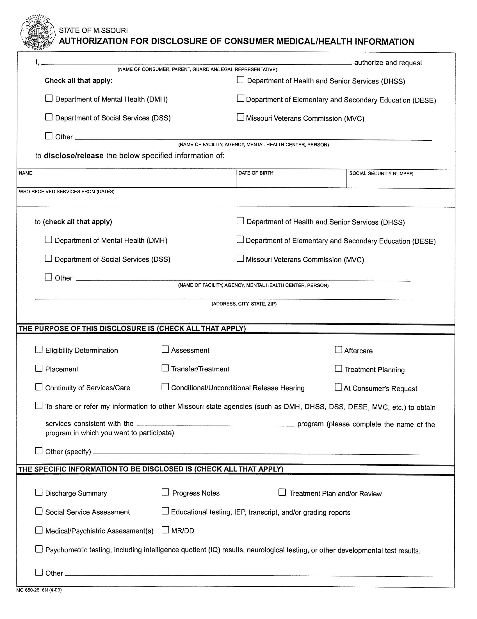

X
X X

X X

X

X Access II Independent Living Center, Inc.

101 Industrial Parkway, Gallatin, MO 64640

X X

X X

X
Independent Living Services

X Any information that may be pertinent with my enrollment in Independent Living Services
1. READ CAREFULLY: I understand that my medical/health information records are confidential. I understand that by signing this authorization, I am allowing the release of my medical/health information.The protected health information (PHI) in my medical record includes mental/behavioral health information. In addition, it may include information relating to sexually transmitted diseases, acquired immunodeficiency syndrome (AIDS), human immunodeficiency virus (HIV), other communicable diseases, and/or alcohol/drug abuse.

2. Alcohol and drug abuse information records are specifically protected by federal regulations (42 CFR 2) and by signing this authorization without restrictions I am allowing the release of any alcohol and/or drug information records (if any) to the agency or person specified
above. Please sign if you are authorizing the release of alcohol and drug abuse information:

3. This authorization includes both information presently compiled and information to be compiled during the course of treatment at the above-named facility or agency paying for services, during the specified time frame.
X 4. This authorization becomes effective on ------------- .This authorization automatically expires on the following

date,eventorspedalcondWon
_ _ _

5. If I fail to specify an expiration date,this authorization will expire in one year.

6. I understand that I have a right to revoke this authorization at any time. I understand that if Irevoke this authorization I must do so IN WRITING and present my written revocation to the health information management department (medical records) or client information center at this facility.I further understand that actions already taken based on this authorization, prior to revocation, will NOT be affected.

7. I understand that I have the right to receive a copy of this authorization. A photographic copy of this authorization is as valid as the original.
8. 1 understand that authorizing the disclosure of this medical/health information is voluntary. I can refuse to sign this authorization. 1 need not sign this form in order to assure treatment. Iunderstand that I may request to inspect or request a copy of information to be used or disclosed, as provided in 45 CFR Section 164.524. I understand that any disclosure of information carries with the potential for an unauthorized redisclosure and the information may not be protected by federal confidentiality rules. If I have questions about disclosure of my medical/health information,Ican contact the health information management director (medical records director) or client information center,or designee, or the Privacy Officer for this covered entity.

THE FOLLOWING APPLIES TO ALCOHOL AND/OR DRUG ABUSE TREATMENT INFORMATION RECORDS:Prohibition of Redisclosure: This information has been disclosed to you from records whose confidentiality is protected by Federallaw.Federal regulations (42 CFR Part
2) prohibit you from making further disclosure of it without the specific written authorization of the person to whom it pertains, or as otherwise specified by such regulations. A general authorization for disclosure of medical or other information is NOT sufficient for this purpose.

My signature below acknowledges that I have read, understand, and authorize the release of my PHI.

SIGNATURE OF CONSUMER
X
WITNESS

SIGNATURE OF PARENT/LEGAL GUARDIAN/REPRESENTATIVE
DATE DATE

(Please include a Description of Authority to Act on Consumer's Behalf and attach a copy of the Document Granting Authority,where applicable)

NOTICE OF REVOCATION
DATE

I, , (Consumer) hereby revoke my authorization of this disclosure of information to the agency/person listed above.This revocation effectively makes null and void any permission for disclosure of information expressly given
by the above authorization.Iunderstand that any actions based on this authorization,prior to revocation,will not be affected.

SIGNATURE OF CONSUMER
DATE

WITNESS
DATE

SIGNATURE OF PARENT/LEGAL GUARDIAN/REPRESENTATIVE DATE

If you choose to revoke your authorization,please provide a copy of the completed revocation to the health information management director
(medical records director),or the client information center, or to the Privacy Officer of this facility.

MO 650-2616N (4-00)

