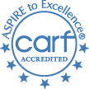
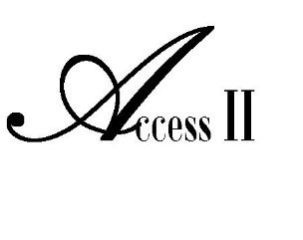
2016 Volume 72
Enabling News
Employment Spotlight
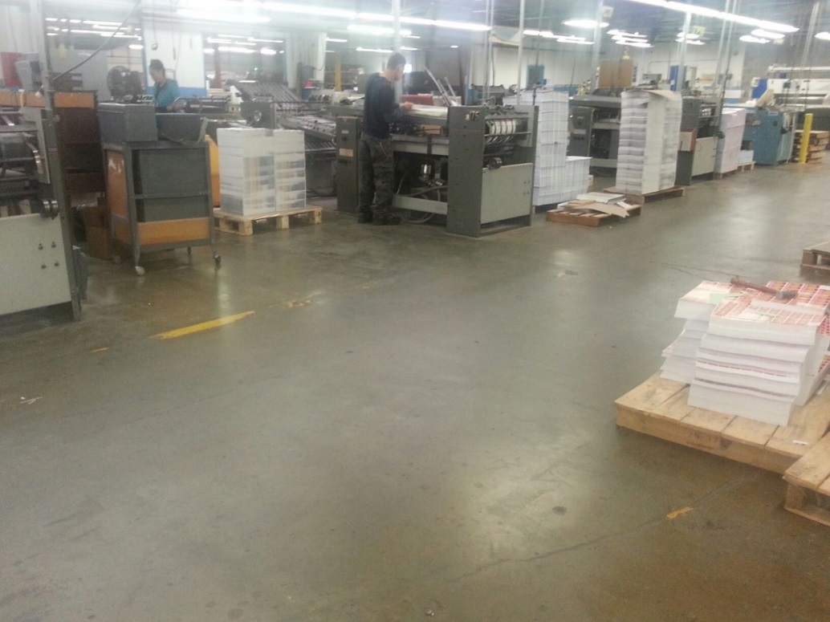
Meet Brian from Richmond, Missouri. Brian came to Access II through a referral from Missouri Vocational Rehabilitation. Brian had recently graduated from high school and was looking for his first job. With no previous experience, no driver’s license, and some employment barriers, Brian knew it might be difficult to find work. Despite those factors he was persistent, and had the support of his family who encouraged him every step of the way. He began working with Access II in May of 2014 and after completing the Discovery and Exploration process he eventually landed a part time job at Walmart. During that time, Brian received assistance from Jessica Adkins, ILS/ Employment Specialist. Brian was prepped in interviewing skills, and had Access II staff present during his interview with Wal-mart. Once the job began, Brian was provided on-site job coaching for a short time. It wasn’t long before Brian was working independently at Walmart where he worked as a stockman for over a year. Brian decided that it was time to advance his career and applied for an operator 1 position at Henry Wurst Inc., one of the largest printing companies in the nation. Brian was offered the job, and now works full-time and has increased his monthly income drastically. He has learned his new job quickly, and now will be working toward moving his way up in the company. Brian found this job on his own and did not need any assistance from Access II Employment staff. Brian has built upon his past work experiences, and learned the skills necessary to find a job on his own. Brian has remarkably increased his independence, income, and has proven he has what it takes to make it in the world of work. If you would like information on Access II’s Employment Program please contact Jessica Adkins at (660)-663-2423 Ext. 231 to discuss your employment goals.
Brian is pictured above loading a machine at Henry Wurst Inc.
Independent Living Center
Your “Access II” disABILITY Resources

Helping Hands Committee
What We’ve Been Doing
For the past few months, Access II has volunteered their time to take on a few new projects. We have recently unveiled our new Committee, The Helping Hands Committee. We have successfully reached out to three of our consumers in the past few months. Your team here at Access II has been to Polo where they participated in raking leaves and shampooing carpets, Carrollton where members participated in winterizing a consumer’s apartment windows and their air conditioner, and have also been to Chillicothe where members ironed clothing, cleaned windows, shampooed furniture, and cleaned out a storage closet.
If you are a consumer of Access II and would like to be considered for the committee’s next Outreach Day, contact Jessica at Access II (660) 663-2423, Extension 231.
Hands Around the Capitol
On October 6th, Access II participated in the Hands Around the Capitol event that took place in Jefferson City. Over 700 people gathered around the Capitol to join hands to celebrate the 25th anniversary of the Americans with Disabilities Act (ADA). Keynote speakers from a variety of backgrounds focused their addresses on the goals of equality for those living with disabilities. Speakers included, youth leaders, lobbyists and former legislators. The event was organized by the Governor’s Council on Disability.
Winston R-VI Food Fight
Winston R-VI sponsors a “food fight” where the school periodically raises non-perishable food items and donates towards a cause. This year Winston chose to donate towards Access II’s Holiday Food Baskets & food pantry. The school donated 466 canned items. Congratulations to the fifth grade on raising the most food items with a total of 116! The fifth grade received a pizza party at the school for raising the most! Thanks again, Winston R-VI for participating in such a great fundraiser!

Winston Trunk or Treat
Access II participated in the Trunk or Treat held at the Winston school in Winston. A variety of organizations set up in the gymnasium to hand out candy to the children. The event was held from 5:30 p.m. until 7:00 p.m. Access II prepared 100 bags of candy and within the first 45 minutes it was gone.
Pictures & Crafts with Santa

Santa pictured waving at the children at South Harrison Elementary

In November, Access II partnered with South Harrison Elementary in Bethany, Missouri providing a night full of fun with Santa. During that event children were able to get their picture taken with Santa, decorate lots of crafts for their family members, and also enjoy cookies & punch with Santa. Santa visited with about 50 kids at the school that evening. Pictures with Santa is one of the two fundraising events Access II sponsors. The other fundraiser is the 5K Color Run, which is held in the spring.

Holiday Food Baskets

On December 17th & 18th, Access II hosted their annual Holiday Food Basket drive. We had about 43 families signed up to receive these baskets. This year we were able to provide a turkey, a bag of potatoes, cans of assorted vegetables and fruit, gravy, and assorted boxes of stuffing for these families. Thank you to Dungy’s Market for ordering all of the turkeys and potatoes, Winston R-IV for donating the canned goods, and WDCH Trucking for their generous food donations.

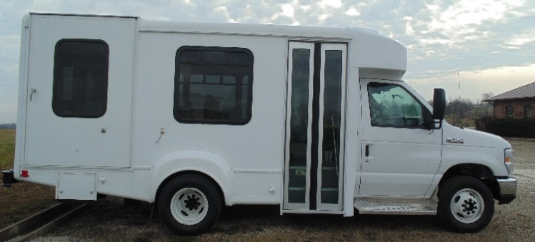
In February 2015, Access II applied for a grant through the Missouri Department of Transportation to purchase a new lift equipped van. This process required several pages of applications, many requirements our office had to meet, and several other things in order to apply for this grant. In August 2015, we found out we had been approved for this new van! We would like to say a special thank you to everyone who has made this possible! If you would like information about our transportation services, please call and speak to Chelsea Rector, ILS/Intake Specialist at 660-663-2423 ext 221.
Access II
Independent Living
disABILITY Resource
Disability Etiquette: Words Make a Difference
Lisa Bowles ILS/Child Advocate/Transition Specialist
One of my favorite quotes regarding good manners is from Emily Post:
“Manners are a sensitive awareness of the feelings of others. If you have that awareness, you have good manners, no matter what fork you use.”
The same sensibility can be applied to the words we choose when speaking with or about an individual with a disability. We are not always going to get it right. Like a lot of subjects, what is considered “right” does change from time to time. However, the philosophy of this quote always applies. We should try to be considerate of others feelings. With that in mind, here are some tips:
- Put the individual with the disability before the disability itself (this is called “person-first language). For example: Instead of saying “My autistic friend” try saying “My friend with Autism”. This makes the person the primary subject, not the person’s disability, relegating the disability to a feature like eye or hair color.
- Try to avoid using the word “Handicapped”. The reserved public parking spaces are “Accessible Spaces”. A van with a wheelchair lift is just that, a wheelchair lift equipped van and not a handicap van.
- A person with a developmental or learning disability should never be referred to as “retarded”. The state of Missouri recently voted to remove that word from their disability related documents. To many, this was way overdue. However, we still hear it from time to time.
- Speak directly to a person with a disability rather than through a companion. If you are having difficulty understanding, relax. Don’t pretend to understand. Repeat what you do understand and, when applicable, ask questions that require only simple short answers or a nod of the head.
If you give these tips a try they will eventually become habit, making you and those around you more comfortable.
ARE YOU ELIGIBLE

For the Missouri Property Tax Credit?
You may be entitled to a refund
IF YOU:

Are 65 Years of Age or Older
OR:

Receiving Veterans
OR:
Social Security Disability Benefits

And
Married: $29,500 annual income or less and Pay Rent
Single: $27,500 annual income or less and Pay Rent
OR
Own your own Home & Pay Real Estate Taxes with an annual income of:
Married: $34,000 or less Single: $30,000 or less

A CCESS II
101 Industrial Parkway Gallatin, MO. 64640
Contact: Marina Beebe- 1-660-663-2423 EXT 229
*** To set up an appointment ***

The required fee for the Missouri Property Tax Credit preparation is $10.00 for individuals eligible to receive a refund, and due at time of service. If an individual has not filed for the Missouri Property Tax Credit and has been eligible for it they may file for the past 3 years.

For Property Tax Credit Claim assistance, you must bring:
- Social security number verification (driver license, social security card, etc.);
- Paid real estate tax receipt for tax year filing. Canceled checks will not be sufficient proof of payment of real estate tax.
- Rental statement from landlord for rent paid for tax year filing. Rental statement must be signed by landlord, address of landlord, telephone number of landlord and TAX I.D # or last four digits of SSA # of landlord.
- Proof of all household income that may apply:
  - Social Security income {Verification letter and /or SSA 1099}
  - Wages {W-2} 1099
  - Interest,Pensions,Annuities,Dividends1099R,1099DIV,1099INT
  - Public Relief
  - SSI/TANF (Assistance to Children)
  - Unemployment benefits
  - Railroad retirement-1099R
  - VA payments –Letter from VA on benefits received
  - Rental income
- If the homestead consists of five acres or more, you must have an Assessor Certification (Form 948) indicating the amount of tax paid on the five acres and your homestead.
- If you own a mobile home and the property tax receipt includes automobiles or other personal property, you must have an Assessor Certification (Form 948).
- Date of Birth, Present home address, Phone number.
** If an individual has not filed for the Missouri Property Tax Credit and has been eligible for it they may file for the past 3 years as well. If filing for previous years, must have documents pertaining to year filing for.

Important information about Medicare Part B premiums for 2016
In 2015, most people pay the Part B premium of $104.90 each month. In 2016, the standard Part B premium amount will be $121.80 (or higher depending on your income). Most people who get Social Security benefits will continue to pay a Part B premium of $104.90 each month. You'll pay a different premium amount in 2016 if:
*You enroll in Part B for the first time in 2016.
*You don't get Social Security benefits.
*You have Medicare and Medicaid, and Medicaid pays your premiums.
*Your modified adjusted gross income as reported on your IRS tax return from 2 years ago is above a certain amount.
If you're in 1 of these 4 groups, here's what you'll pay:

If your yearly income in 2014 (for what you pay in 2016) was |  |  | You pay (in 2016)
File individual tax return | File joint tax return | File married & separate tax return
$85,000 or less | $170,000 or less | $85,000 or less | $121.80
above $85,000 up to $107,000 | above $170,000 up to $214,000 | Not applicable | $170.50
above $107,000 up to $160,000 | above $214,000 up to $320,000 | Not applicable | $243.60
above $160,000 up to $214,000 | above $320,000 up to $428,000 | above $85,000 and up to $129,000 | $316.70
above $214,000 | above $428,000 | above $129,000 | $389.80
As a certified CLAIM Medicare counselor I can answer your questions about the 2016 changes to Medicare. All information is confidential- services are at no cost. Call today for an appointment.

Marina Beebe-1-660-663-2423 Extension 229

Calendar of Events
December
24 Staff Meeting & Christmas Eve – Center Closed
25 Christmas Day – Center Closed Dec. 25 – Jan 1
January
01 New Year’s Day – Center Closed
18 Martin Luther King Jr Day – Center Closed
21 Staff Day – Center Closed
February
15 President’s Day – Center Closed
18 Staff Day – Center Closed
20 Polar Plunge
March
17 Staff Day – Center Closed
25 Good Friday – Center Closed
Office Hours
8 a.m. – 4:30 p.m.
Monday-Friday
Check out our website at www.accessii.org ~ We will be undergoing changes!

Find us on:

STAFF
Executive Director
Heather Swymeler
Financial Director
Amber Wells
Program Manager
Brandy Gannan
Benefits Specialist/ILS/TAP
Marina Beebe
Employment Specialist/ILS
Jessica Adkins
In-Home Director
Dawn Litton
LPN
Samantha Brewer
CDS Case Mgr/ILS
Jen Miller
CDS Payroll Specialist
Staci Hamilton
ILS/Child Advocate/Transitions
Lisa Bowles
ILS/Intake Specialist
Chelsea Rector
BOARD
President
Annie Gibson
Vice President
James Ross
Secretary
Leslie Stanley
Treasurer
David Arnold
MEMBERS
Tim Tadlock
Stacey Maxwell

NOT FOR PROFIT ORG.
U. S. POSTAGE PAID
PERMIT NO. 30
GALLATIN, MO 64640

Access II, Independent Living Center
101 Industrial Parkway
Gallatin, MO 64640

