Enabling News
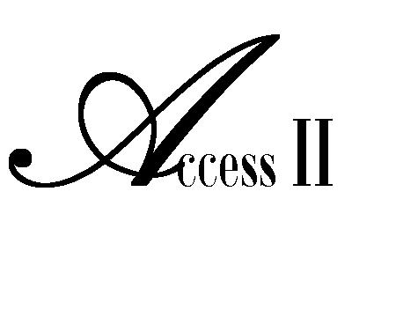

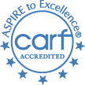

WINTER 2013 VOLUME 62
Independent Living Center

.
ACCESS II ILC launches three year
FEATURE
ARTICLE
Show-Me-Careers Project!!

Local partnership backed by statewide initiative works to improve the lives of youth
with disabilities transitioning from school to community-based employment.

Ice may still be on the ground in some places, but spring isn’t far away. For our high school seniors, this means graduation time. Crossing the threshold of adulthood is quickly approaching.
Graduates with developmental and intellectual disabilities share the same hopes and dreams held by their peers without disabilities. Many want to find a path leading to a career they enjoy that supports them financially and unites them with their home community, surrounded by family and friends.
But sadly, job opportunities for youth with developmental and intellectual disabilities can be hard to find. While national figures report 19 percent of people with developmental disabilities work in community settings, at or above minimum wage, Missouri falls behind at only seven percent (ICI State Data Report, 2011).
Access II is working to improve options for young adults with intellectual and developmental disabilities. As one of eight “pilot communities” supported by the statewide Show-Me-Careers school to career initiative, Access II was chosen through a competitive application process to test ideas on how to bring real and lasting change. Lessons learned through our local efforts will become a guide for other Missouri towns and cities in the future.
Access II Independent Living Center is a Center for Independent Living serving the Missouri counties of Caldwell, Carroll, Daviess, Grundy, Harrison, Livingston, Mercer, and Ray. Access II is a consumer-controlled, community based, nonresidential program, designed to promote independent living opportunities and improve quality of life for persons with disabilities. Access II serves persons with any disability, any age, with no income or eligibility criteria. Access II will continue to partner with Missouri Department of Vocational Rehabilitation in Chillicothe, Missouri whose mission is to ensure that Missouri Vocational Rehabilitation provides the highest quality of employment oriented services to Missourians with disabilities.
Youth participants will have an opportunity to interact with employers and project business partners. Early work experience will be sought through these partnerships. Walgreens, located in Chillicothe, Missouri, as a business partner will provide information regarding skills employers are seeking.
Additional business located in Harrison, Grundy, and Livingston counties will be sought to partner with the project participants and assist our communities in creating inclusive work environments; increasing the number of youth and young adults with developmental and intellectual disabilities to participate in paid, inclusive community employment.
Access II staff will conduct career exploration and work readiness modules in targeted schools and targeted community settings. These modules will prepare participants for more successful post-secondary education and/or employment experiences. These career exploration classes include job interviewing, budgeting, self-determination, and practical employment skills. As part of this project, current career exploration classes will continue and be expanded to include even more individuals with developmental and intellectual disabilities and will allow for one-on-one career guidance.
Specific partnership schools within these communities are Trenton R-IX High School, Cainsville R-I High School, Ridgeway R-V High School, and Chillicothe R-II Alternative School. Individuals with developmental and intellectual disabilities will also play a vital role in the development of the services offered through this project.
“We have partnered with schools prior to this particular initiative and have had a great response from the teachers and students with our career exploration seminars. This funding allows Access II to go a step further to involve families as part of the team to encourage students and young people. The addition of partnering with businesses to offer an on the job training program will bring a reality of the responsibilities of an employee to their work site. Ultimately, our goal is the businesses will give our youth opportunities and experiences, then realize their value and potential as employees and give them a job. The Show-Me-Careers initiative is a win for everyone involved.” Stated Heather Swymeler, Executive Director of Access II.
Financial support, coaching, leadership training and technical support for our project will be provided by the statewide Show-Me-Careers leadership consortium. Show-Me-Careers has an overall goal to increase the number of youth and young adults ages 16 through 30 working in paid jobs that are part of the larger community.
Show-Me-Careers funding is provided by the U.S. Department of Health and Human Services (DHHS), Administration for Community Living (ACL), and Administration on Intellectual and Developmental Disabilities (AIDD). The award is part of AIDD’s nationwide effort to improve existing state systems and lead in the development of policies and practices that increase competitive employment outcomes for youth and young adults with disabilities.

For more information, contact Tanya Farrell at Access II’s office, (888) 663-2423 ext. 228.
###
~ Check out what we’ve been doing! ~

NOVEMBER 2012:

Festival of Trees

Access II held their second annual Festival of Trees fundraiser on Friday, November 30. The event included horse & buggy rides, crafts for children, pictures with Santa and Mrs. Claus, cookies and hot chocolate supplied by the Gallatin area TOPS group, memory sky lanterns and the auction of over two dozen trees, wreaths and holiday décor. Heather Swymeler, Access II’s Executive Director, estimated over 200 people participated in the fun evening event. “The Festival of Trees is one of only two fundraisers the Center sponsors each year. Our other fundraiser will be a 5k Walk, Run or Roll in the late spring. The Tree Festival has decorated trees, wreaths, arrangements and baskets donated by several businesses, groups and individuals which are auctioned off by silent bid at the end of the evening. So bidders may take home a fully decorated tree or beautiful arrangement. Our Staff has also donated some wonderful pieces as well as worked to make this event a success. We have expanded the event from last year. The buggy rides were a fun addition. Staci Hamilton had the idea for the memory sky lanterns which we lit and sent off as a group at 7:30. It was a beautiful sight with all the colored lanterns lit up; going into the sky with all the good wishes and memories of loved ones. It was hard to tell who was more excited, the kids or the adults.” The mission of Access II Independent Living Center is to provide programs and services that encourage and help sustain greater independence for persons with disabilities within our communities. The Center’s four core services are information and referral, peer counseling, advocacy and independent living skills training. Access II has a variety of funders including private donations and money raised through yearly fundraisers such as the Festival of Trees. Ms. Swymeler said “We want to thank everyone that came out to support Access II’s efforts. We appreciate Kelly Pingleton for her photography skills, Green Hills Riding Academy, Fred and Terri White for their generous time, all the people that donated the trees and wreaths, the friends and family of the Access II Staff for all their help and certainly the people that bid on the items and opened their wallets to make this fundraiser a success. The Committee is already making plans for next year’s event which I am sure will be even bigger. From our Staff and all our volunteers, I want to wish everyone a bountiful New Year and again, thank you for your generosity.”

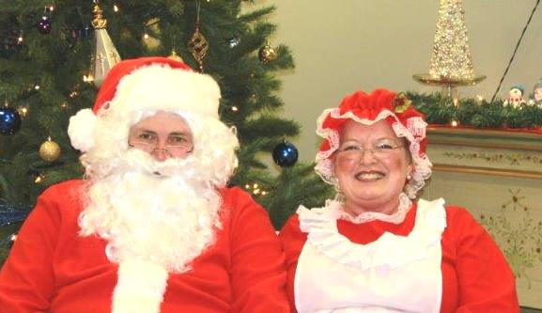
DECEMBER 2012:

Christmas Food Baskets

On December 21, we hosted our annual Christmas Food Basket drive. Twenty-eight families signed up and weathered the snow and ice to pick up their baskets of food at our office. This year, we were able to provide each family a turkey, a bag of potatoes, six cans of assorted vegetables, and a large bag of mixed, fresh fruit. Thank you goes to the Gallatin High School FFA for the generous gift of fresh oranges, grapefruit, and apples. We also thank the Jamesport Country Store for the donation of 35 sturdy, nylon grocery bags that we used for the canned goods. Through their generous support, we were able to help 56 people have a more plentiful Christmas meal.

JANUARY 2013:

3rd Annual “Access II” A New You Weight Loss Challenge
We kicked off our 3rd Annual “Access II” A New You Weight Loss Challenge on Jan. 8th! We have 18 participants who are losing weight and learning to eat healthier. The challenge is for 16 weeks and ends on April 30, 2013. We hope the participants will join us for our 2nd Annual Walk It ~ Run It ~ Roll It 5K/10K on Saturday, May 4th.

Legislative Committee Meets with State Legislators
On Januray 29th, Access II’s Legislative Committee, consisting of Dawn Ernat, Amy Corzette, and Angela Hogan, visited six of our seven State Legislators in Jefferson City. We met with Representatives Casey Guernsey, Mike Lair, Joe Don McGaugh, Jim Neely, Nathan Walker, and Senator David Pearce. The staff explained some of Access II’s programs and services and we discussed the possibility of a Medicaid expansion under The Affordable Care Act.

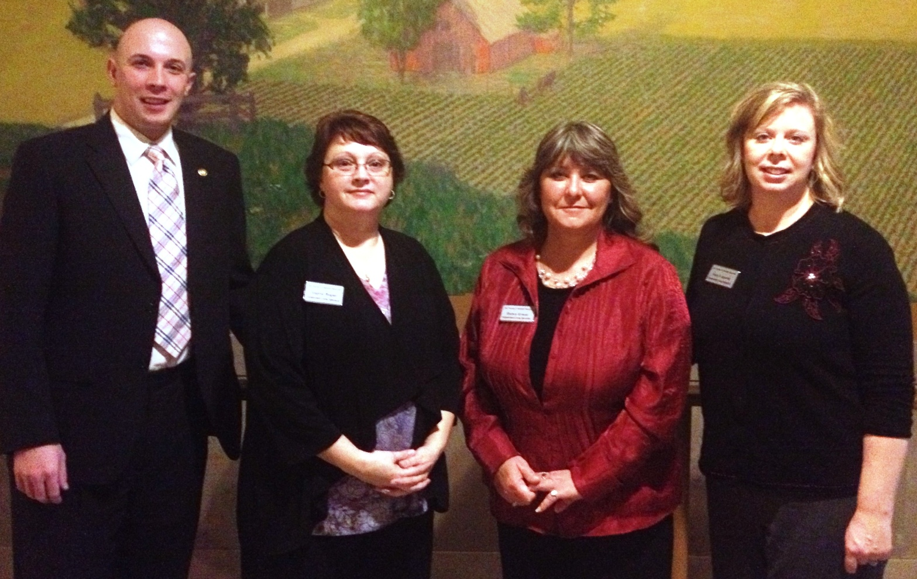
From left to right: Representative Casey Guernsey, Angela Hogan, Dawn Ernat, and Amy Corzette

Spotlight on our programs:

Employment Training Program
“I do not believe we can repair the basic fabric of society until people who are willing to work have work. Work organizes life. It gives structure and discipline to life.”
Former President, Bill Clinton said this when he was asked about an employment act he was backing in Congress. Having a job, feeling like you are contributing to the economics of the nation and really, getting a paycheck is an important part of life. For those of us over the age of 18, do you remember your first job? As a kid, I used to babysit, clean my older sister’s house and like many other young girls my age in Iowa, I detassled corn during the summer. Seeing my name on a paycheck, having a few dollars in my pocket was a wonderful feeling. I am way older than 18 now and getting a paycheck is still a wonderful feeling and those few bucks in my pocket are great.
Access II has been granted CARF (Commission on Accreditation of Rehabilitation Facilities) certified for employment services. Because of this accreditation, Access II is now an employment services provider for the Missouri Vocational Rehabilitation offices. This new program assists our mutual clients develop very important employment skills such as resume writing, networking techniques, interviewing skills, business etiquette and how to keep a job once you find one. Sometimes, it is those “soft skills” that trip up often, very qualified job candidates. We can help!
Did you know that less than 7% of jobs are found through a newspaper or internet advertisement? Most jobs are obtained through networking--- talking to everyone you know, everyone you meet, telling them that you are looking for a job and if they hear or know about anything, to give you a call. The old adage “it’s not so much what you know, but who you know…” has never been truer. When you are looking for employment, tell every person you know and ask them to tell everyone they know about you!
Americans with disabilities are able to make enormous contributions to our economic recovery if we make modest accommodations to let them utilize their talent. Almost 8 in 10 adults with a disability are currently out of the workforce — compared to 3 in 10 for those without a disability. For Americans with disabilities who come from underserved and historically excluded communities, finding a job today can be especially difficult.
Through Access II’s employment program, we can help open doors to employment. We will work closely to assist employers make accommodations for qualified candidates. Together we can make a difference in the workplace and in lives. And just maybe, more people will have that great feeling a few bucks in their pockets. Give me a call. Let’s talk about jobs!
For more information, please call our office at (888) 663-2423 and speak with Licha Kelley-King, ext. 231

~ Upcoming Events ~
APRIL
April 9th is Disability Rights Legislative Day at the MO State Capital in Jefferson City, MO. Please feel free to contact your State Legislator or to attend the event to discuss your ideas and views about your disability rights.
MAY
Access II is having our 2nd Annual ~Walk It ~Run It ~Roll It 5K/10K… an event for all ABILITIES on May 4, 2013. Our goal is to chase away the common perception of disability from the minds of all our communities and to promote community wellness while providing a race that is for everyone.
Participate in a fun, healthy community activity and start training with a purpose toward some great and rewarding goals. Even if someone has never entered a race like this before, this is just the event to jumpstart the “Access II” a New You. We highly encourage you to join us for this fabulous event!
For more information and to have a registration form mailed to you, please call Access II’s office at (888)663-2423 and speak with Angela Hogan, extension 221.

ARE YOU ELIGIBLE

For the Missouri Property Tax Credit??

You may be entitled to a refund

IF YOU:

Are 65 Years of Age or Older
OR:

Receiving Veteran’s Benefits
OR:
Social Security Disability Benefits

And
Married: $29,500 annual income or less and Pay Rent
Single: $27,500 annual income or less and Pay Rent
OR
Own your own Home & Pay Real Estate Taxes with an annual income of:
Married: $34,000 or less
Single: $30,000 or less

A CCESS II
Independent Living Center
101 Industrial Parkway Gallatin, MO. 64640
*** To set up an appointment ***
Contact: Marina Beebe at (888) 663-2423 EXT 229

For Property Tax Credit Claim assistance,
You must bring to your appointment:
- Social security number verification (driver’s license, social security card, etc.)
- Paid real estate tax receipt - Canceled checks will not be sufficient proof of payment of real estate tax. (If you pay rent, you must provide copies of rent receipts signed by your landlord that include landlord's name, social security number, and address. If your landlord will not provide rent receipts, copies of canceled checks will be accepted as sufficient proof of payment of rent; however, you still must provide the address and phone number of your landlord.
- Proof of all household income that may apply:
  - Social Security
  - Wages
  - Interest-Pensions-Annuities-Dividends
  - Public Relief
  - SSI/TANF (Assistance to Children)
  - Unemployment benefits
  - Railroad retirement
  - VA payments
  - Rental income
- If the homestead consists of five acres or more, you must have an Assessor Certification (Form 948) indicating the amount of tax paid on the five acres and your homestead.
- If you own a mobile home and the property tax receipt includes automobiles or other personal property, you must have an Assessor Certification (Form 948).
- Date of Birth, Present home address, Phone number.
- If an individual has not filed for the Missouri Property Tax Credit and has been eligible for it they may file for the past 3 years as well. If filing for previous years, must have documents pertaining to year filing for.

Fact Sheet
Medicaid Expansion in Missouri – A potential windfall of $1.327 billion per year for each of the next six years.

In 2010 Congress enacted the Affordable Care Act. One part of this legislation mandated that all States expand their Medicaid to all persons whose incomes are under 138% of the federal poverty level, which is less than $15,415 per year for a single person and less than $31,809 for a family of four. In June 2012, the U.S. Supreme Court held that Medicaid Expansion could not be a mandate, making Medicaid Expansion optional for States.

This Fact Sheet explains why Medicaid Expansion will be a major source of new federal funds and a significant driver of Missouri’s economy. That is why it is vitally in Missouri’s economic interest to opt to provide for Medicaid Expansion.

Medicaid Expansion represents new federal dollars available to Missouri. These otherwise unavailable federal dollars will create jobs, provide new state tax revenue and stimulate the state economy. Hospitals, nursing homes, managed care organizations, medical supply firms, and physicians will directly benefit. Medicaid Expansion funds will create a major ripple effect throughout Missouri’s economy, spurring job creation and benefiting both the public and private sectors.

- In Missouri, there are about 402,000 people whose incomes are under 138% of the federal poverty level but who are not currently eligible for Medicaid for other reasons. These people will be Medicaid eligible after Missouri’s “Medicaid Expansion.”

- The Centers for Medicare and Medicaid Services (“CMS”), the federal agency that administers Medicaid, has reminded States that “while States have flexibility to start or stop the expansion, the applicable federal match rates [for the Medicaid Expansion] … are tied by law [Congress] to specific calendar years…; States will receive

100 percent [federal financial assistance] … in 2014, 2015 and 2016;
95 percent in 2017,
94 percent in 2018,
93 percent in 2019, and
90 percent by 2020, remaining at that level thereafter.”

- This means the federal government will pay for all the Medicaid costs for the 402,000 people under 138% of the federal poverty level in Missouri between 2014 and 2016 -- the entire 100% of their Medicaid. Yes, it will be an enormous influx of federal funds with no Missouri match. Between 2017 through 2019, the federal reimbursement will decrease a little, but never fall below 90 percent.

- Contrast these federal reimbursements for Medicaid Expansion with what the federal government presently matches Missouri for the 779,600 people who already receive Medicaid. The present federal reimbursement rate is only 63.4% and Missouri pays the remaining 36.6%, as compared to the 90 - 100% federal reimbursement rate for Medicaid Expansion!

- What if Congress in a few years changes its mind or changes these percentages? Is Missouri stuck with the expansion? CMS was asked “if a State accepts the [federal] expansion [funds], can a state later drop out of the expansion program?” CMS responded “Yes. A State may choose whether and when to expand [coverage], and if a state covers the expansion group, it may decide later to drop the coverage.”

- Is it administratively difficult or time-consuming for a State to enter the Medicaid Expansion program? As with other parts of a Medicaid State plan, it’s easy for States to sign up. A State need only notify CMS that it has amended its Medicaid State Plan to include persons whose incomes are under 138% of the federal poverty level. This is a very simple process which can be done on-line or by letter. Similarly, “if a state later chooses to discontinue coverage …, it would submit another state plan amendment to CMS” notifying CMS it no longer will cover the group under 138% of the federal poverty level.

- Let’s take a six year view for Missouri. From 2014 through 2019, the federal dollars for the Medicaid Expansion will come to about $8.395 billion. Those federal dollars will cost Missouri $431 million over the six years as a match.

- That’s a 19.50 to 1 federal to state match! Is there any business in Missouri which would not put up one dollar to receive 19.50 dollars? It’s hard to imagine a business that would refuse such a rate of return, especially if the business could always drop out of the Medicaid Expansion without any penalty or loss.

- It has been estimated that this $1.327 billion in new federal funds between 2014 and 2019 will only increase by 1.7% what Missouri would have spent if it had not participated in this Medicaid Expansion. Why would Missouri NOT expand?

- Over the next six years that is a net gain of $7.964 billion dollars. An average federal gain of $1.327 billion per year for Missouri!!! If you are interested in economic development and can kick in $1.327 billion per year into the State for anything, whether highway construction, foster care and adoption assistance, or Medicaid, that $1.327 billion is going to help the State.

- If Missouri does not enroll the 402,000 low-income people in Medicaid Expansion, the State will actually lose federal reimbursements it had previously received. When the Affordable Care Act was passed, Congress assumed every State would expand coverage to families whose incomes are less than 138% of the federal poverty level. Congress also reduced special hospital payments that had been providing a disproportionate share of reimbursements for hospital services to the lowest income residents. Congress significantly reduced these special reimbursements because it assumed that the hospitals would be reimbursed under the regular Medicaid program for serving the Medicaid Expansion population.

- Therefore, if Missouri does not agree to Medicaid Expansion, the State and hospitals will lose about $332 million in federal reimbursements per year without receiving in its place the stream of reimbursements that Medicaid Expansion would have provided! That means jobs, as well as health care services. Over the same six years, this loss of special hospital payments will amount to about $1.994 billion. Any way one cuts it, this loss is far more than what Missouri would spend if it agreed to the Medicaid Expansion.

- It makes simple business sense to accept the $8.395 billion in Medicaid Expansion, because Missouri and its hospitals will lose $1.994 billion over the six years regardless. Why not come up with $431 million in state funds spread over 6 years to finance Medicaid Expansion which will then ensure and provide for the tremendous financial benefits to the hospitals?

- One could also look at potential increases in revenue for the health care industry. For example, if Missouri participates in the Medicaid Expansion, this will generate about $881,123,700 per year in new hospital revenues. That means new jobs at all economic levels.

- Besides hospitals, other health-related industries will similarly benefit, including pharmaceutical and managed care companies because there will be 402,000 new Medicaid recipients to use their services.

Medicaid Expansion is a win-win: it increases both health care access and the amount of federal funds put into Missouri’s economy.

Fact Sheet prepared by Stephen F. Gold, Esq., 215-627-7100, ext 227.
For more information, citations, and data, contact stevegoldada1@gmail.com.

Important Information for individuals receiving Federal Benefits
2013 Social Security Changes Cost-of-Living Adjustment

Based on the increase in the Consumer Price Index (CPI-W) from the third quarter of 2011 through the third quarter of 2012, Social Security and Supplemental Security Income (SSI) beneficiaries will receive a 1.7 percent COLA for 2013.

Other important 2013 Social Security information is as follows:

Substantial Gainful Activity (SGA) 2012- Non-Blind $1,010/mo. 2013 - $1,040/mo.
2012 Blind $1,690/mo. 2013 - $1,740/mo.

Trial Work Period (TWP) 2012- $ 720/mo. 2013- $ 750/mo.

SSI Federal Payment Standard: Individual 2012 - $698.00 2013- $710/mo.
Couple 2012 - $1,048/mo. 2013 - $1,066/mo.

SSI Resources Limits: 2013-Individual $2,000 2013 - Couple $3,000

SSI Student Exclusion: Monthly limit 2012- $1,700 2013- $1,730
Annual limit 2012 - $6,840 2013 - $6,960

Estimated Average Monthly Social Security Benefits Payable in January 2013:

All Retired Workers 2012-$1,240 2013- $1,261

Aged Couple, Both Receiving Benefits 2012-$2,014 2013- $2,048

Widowed Mother and Two Children 2012- $2,549 2013- $2,592

Aged Widow(er) Alone 2012- $1,194 2013- $1,214

Disabled Worker (1 or more child} 2012- $1,887 2013- $1,919

All Disabled Workers 2012- $1,113 2013- $1,132

If you have any questions or need assistance with your benefits please call. All services are at no cost to consumer and information obtained is confidential.

Marina Beebe, Benefits Specialist - Independent Living Specialist
(888) 663-2423, EXT 229

Success Stories from our Transitions Program
Bud truly has an inspiring story, I met him about 6 months ago after he had recently moved into the Residential Care side of a nursing home in Livingston county. Bud had a guardian who was the public administrator and wanted to leave the facility and move out on his own. A plan was put into place in regards to Bud and the possibility of him leaving the RCF. After a period of 6 months where Bud could show he was capable of taking care of his own affairs and with the help from Access II, Bud was able to go to court and get his guardianship terminated and move out into his own apartment. The process was not fast but with his hard work and with supports put into place we were able to help Bud gain his independence back. Bud is now very happy and is doing really well on his own. What a great story!
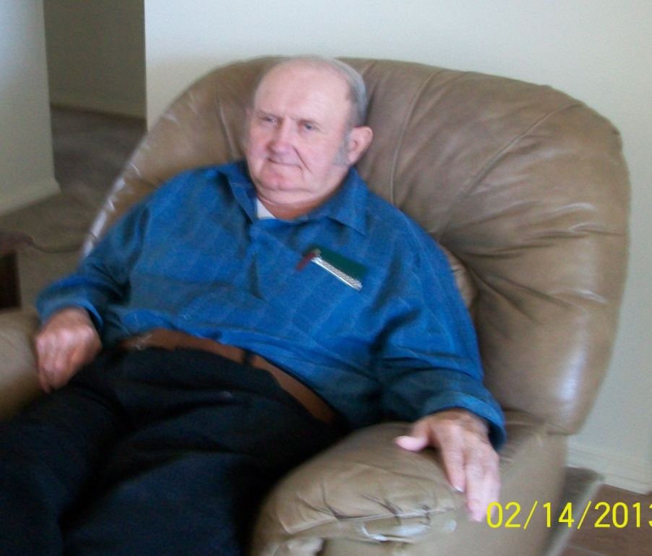
Doris is the story of the perfect transition. She had been in a nursing home in Livingston County for about 3 months when I met her and was desperate to leave and live on her own. Doris was in need of additional help at home, but her family was not aware of services that are available for the elderly or individuals with disabilities and had decided that the nursing home was the best place for her. After a period of time we were able to find affordable housing for her and get her approved for in-home services. We helped Doris move out of the nursing home and she now lives on her own while receiving the help she needs every day. After 18 weeks on her own, she is doing great and loving her independence.

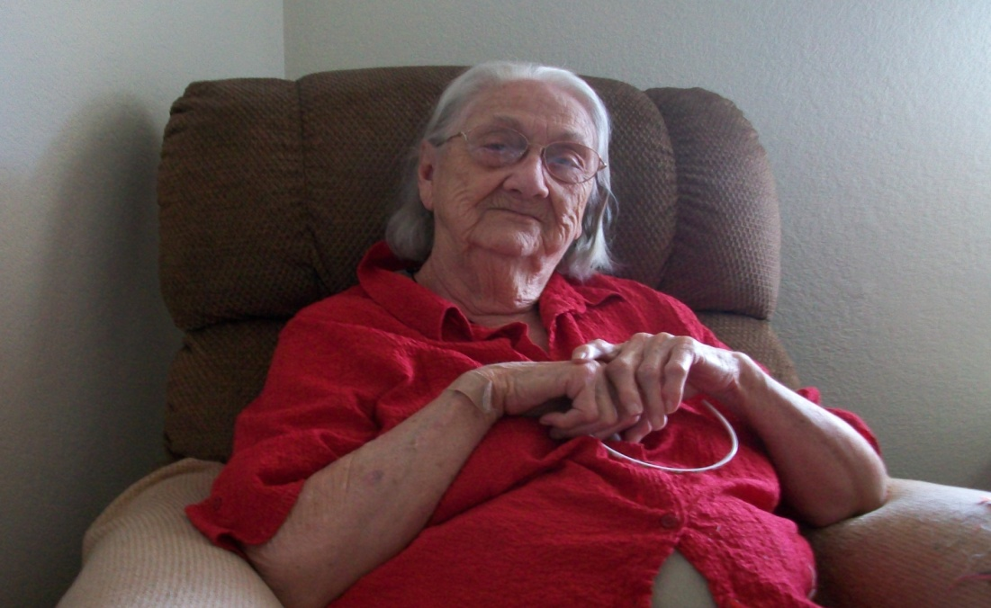
Access II, Independent Living Center
101 Industrial Parkway
Gallatin, MO 64640

NOT FOR PROFIT ORG.
U. S. POSTAGE PAID
PERMIT NO. 30
GALLATIN, MO 64640

~~ LIKE OUR FACEBOOK PAGE~~

Scan our QRC Code
with your smart phone!!

Calendar of Events

March

26 Board Meeting
29 Good Friday – Office Closed

April

9 Disability Rights Legislative Day in Jefferson City
23 Board Meeting

May

4 Walk It, Run It, Roll It 5K/10K
27 Memorial Day – Office Closed 28 Board Meeting

June

25 Board Meeting

Office Hours:
8 a.m. – 4:30 p.m.
STAFF

Executive Director
Heather Swymeler
Financial Director
Vicki Corwin
Program Manager
Tanya Farrell
Child Advocate/ILS
Georgia Jackson
Benefits Specialist/ILS/TAP
Marina Beebe
Employment Training /ILS
Licha Kelley-King
ILS/CDS
Vickie Tolen
ILS/CDS
Brandy Gannan
ILS/CDS
Dawn Ernat
CDS Payroll Specialist
Staci Hamilton
Transitions/Home Mods/TAP
Amy Corzette
ILS/Intake
Angela Hogan

BOARD
President
Annie Gibson

Vice President
Tim Tadlock

Secretary
Leslie Stanley

Treasurer
William Cullen

MEMBERS
David Arnold
Dana Brookbank
Scott Marshall

Check out our website at www.accessii.org

http://www.urban.org/UploadedPDF/412607-Opting-Out-of-the-Medicaid-Expansion-Under-the-ACA.pdf
http://cciio.cms.gov/resources/files/exchanges-faqs-12-10-2012.pdf at 11.
http:// www.statehealthfacts.org /profile.jsp
http://aspe.hhs.gov/health/fmap12.shtml
http://cciio.cms.gov/resources/files/exchanges-faqs-12-10-2012.pdf at 11.
Id.
http://www.kff.org/healthreform/upload/medicaid-coverage-and-spending-in-health-reform-national-and-state-by-state-results-for-adults-at-or-below-133-fpl.pdf Table 1 at 10, column 5.
Id. at column 4.
Id. at column 9.
This was computed by subtracting the six year State match of $431 million from the federal match of $8.395 billion and then dividing by six.
This represents the total Medicaid Inpatient Hospital –Disproportionate Share Hospital (DSH) payments in 2010 multiplied by the federal match in # 4 above.
This amount is derived by computing Missouri’s average current Medicaid recipient’s Medicaid hospital costs and multiplying that by the number of people who will be enrolled in Missouri’s Medicaid Expansion.

