Enabling News
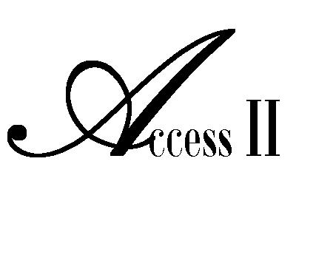
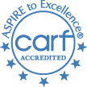

SPRING 2014 VOLUME 66
Independent Living Center

. Access II Hosts
FEATURE
ARTICLE
Annual Weight Loss Challenge and
Walk It ~ Run It ~ Roll It 5K Color
Access II hosted its 4th annual Weight Loss Challenge. The challenge began on January 14, 2014 and continued for twelve weeks with the final weigh-in on April 8, 2014. We had eleven participants this year with two different categories. The participants lost a combined total of 96.6 pounds. The winner from the 18-40 age category was Ashley, who lost a total of 19.6 pounds. The winner from the 41 & Over age category was Mary, who lost a total of 19.4 pounds. The winners were based on the total percent of weight lost. The 12 week challenge ended with our Walk It-Run It- Roll It 5K Color Run on April 5, 2014.
The Color Run was a success. We had 57 participants on race day. The route consisted of five color stations at each 1K mark. As the participants went by each station they were covered in color. Access II staff had an amazing time tossing color on our participants. By the end of the race everyone was very colorful. The goal of this event is to chase away the common perception of disability from the minds of all communities and to promote community wellness while providing a race that is for EVERYONE.
Access II would like to thank everyone for their support and participation in this event. We would also like to thank our sponsors for their generous support: Landmark Reality, Dungy's Grocery, BTC Bank, Robertson Insurance Services, McCoy and Samples Dental Clinic, and Premier Eyecare Associates. We can’t wait to do this again next year!

For more information, contact Brandy Gannan at Access II’s office, (888) 663-2423 ext. 233.
Check out what else we’ve been doing:
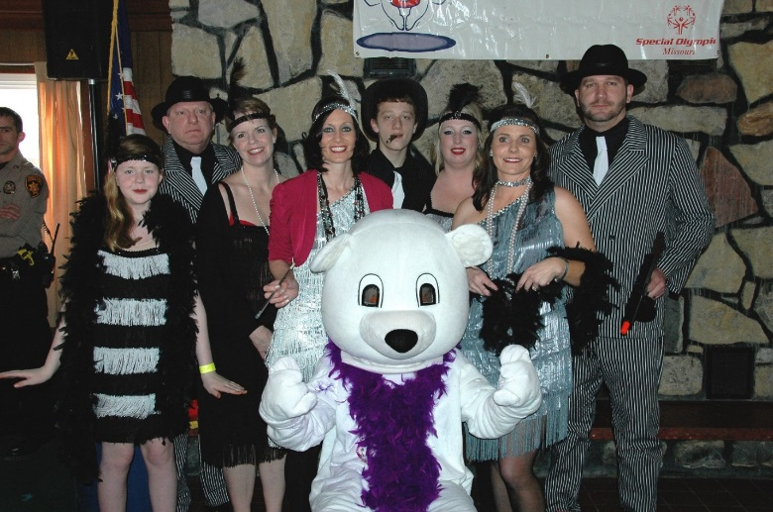

Access II Volunteers Freeze for a Reason!!!

Members of Access II’s Polar Plunge team braved the icy waters of Lake Viking on February 22nd for the 2014 Polar Plunge benefitting Special Olympics, Missouri. Costume-clad teams subjected themselves to the brutal elements for this worthy cause, raising a combined total of $26,000.
Access II was honored with the coveted “Golden Plunger”, taking first place in the costume contest for their flappers and Gangsters theme. We are already looking forward to next year’s event.

For more information, contact Lisa Reagh at Access II’s office, (888) 663-2423 ext. 221.
Access II Employees, Consumers Attend Legislative Days

Karma Fisher and Jen Miller have attended two legislative days at the state capital in Jefferson City so far this year. The first was held March 12th and was a rescheduled date for legislation concerning Money Follows the Person, a program which assists nursing home residents move back out into their community safely. Karma and Jen met with several representatives from our various counties and discussed why Money Follows the Person grant and the Transitions program are so important. The second was Disability Awareness Day and was held on April 2nd. Along with Karma and Jen, Jessica Adkins, Employment Specialist, and consumers James and Kristina went. These two consumers are very active in letting our legislators know what issues are important to them. Some topics that were discussed include bullying, transportation in rural communities, case management services, and accessibility for persons who are hard of hearing or deaf. Fun was had by all who attended and we are very much looking forward to our next opportunity to advocate on behalf of individuals with disabilities.

For more information, contact Dawn Ernat at Access II’s office, (888) 663-2423 ext. 228.

Access II Welcomes New Staff Member!!!

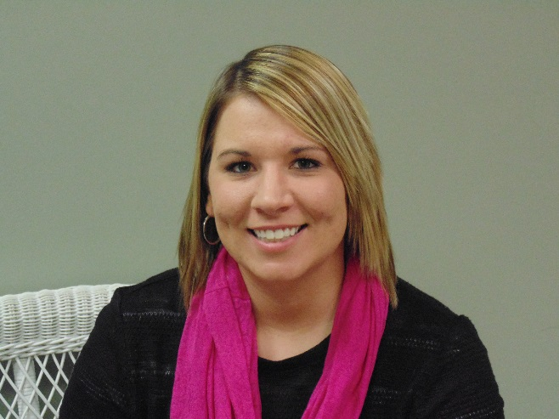
Hello! My name is Sarah (Anthofer) Miller and I am very excited to be part of the Consumer Directed Services team at Access II. I am originally from small-town Exira, Iowa. I attended Northwest Missouri State University for four years for Biological Sciences and Missouri Western State University for Law Enforcement Academy and Criminal Justice. I will graduate with my Bachelor’s Degree in May of this year. My past experiences include working as a Deputy Sheriff and as a Specialized Victim Advocate for a domestic/sexual violence shelter. This past August (2013), I married my best friend, Joshua, who is originally from Kansas and now works as a police officer for Trenton Police Department. We have an (unofficially) adopted 15 year old daughter, Brittany, and a 70 pound Great Dane, Maverick, that keep us busy at our home in Gallatin. My faith and my family are what I cherish most.

Spotlight on our programs:

Access II Now Providing In-Home Care Services
Access II can now assist you with activities of daily living by providing an in-home aide to allow you to achieve greater independence in your home and community. In-Home Services include:

- Dietary
- Dressing and grooming
- Bathing and personal hygiene
- Toileting and continence
- Assisting with Mobility and transfer
- Medically related household tasks
- Launder clothes
- Shop for essential items

- Perform essential errands
- Read and write correspondence
- Wash dishes
- Clean kitchen
- Clean bathroom
- Make beds
- Medication set-up
- Nursing care
- Diabetic care
- And Much More!

For more information, contact Lisa Reagh at Access II’s office, (888) 663-2423 ext. 221.

Upcoming Events

Second Grade Learning Day

Access II will be hosting “Second Grade Learning Day” for Gallatin School District in May. Our staff is planning a special day full of fun activities designed to teach healthy habits and disability awareness.

For more information, contact Jessica Boggess at Access II’s office, (888) 663-2423 ext. 230.

Access II’s 4th Annual Art Show
Plans are being made for Access II’s 4th Annual Art Show and Sale. This much anticipated event will take place in September. It will feature artwork from many of Access II’s consumers and all proceeds from sales of the artwork go directly to the artists.
For more information, contact Jessica Adkins at Access II’s office, (888) 663-2423 ext. 231.

NOT FOR PROFIT ORG.
U. S. POSTAGE PAID
PERMIT NO. 30
GALLATIN, MO 64640

Access II, Independent Living Center
101 Industrial Parkway
Gallatin, MO 64640

BOARD
President
Annie Gibson
Vice President
David Arnold
Secretary
Leslie Stanley
Treasurer
Kimbra Mullenix
MEMBERS
Tim Tadlock
Dana Brookbank

STAFF

Executive Director
Heather Swymeler
Financial Director
Amber Wells
Program Manager
Brandy Gannan
Child Advocate/ILS
Jessica Boggess
Benefits Specialist/ILS/TAP
Marina Beebe
Employment Training /ILS
Jessica Adkins
In-Home Director
Dawn Ernat
ILS/CDS
Jen Miller
ILS/CDS
Sarah Miller
CDS Payroll Specialist
Staci Hamilton
Transitions/Home Mods/TAP
Karma Fisher
ILS/Intake
Lisa Reagh

Calendar of Events

May
14 2nd Grade Learning Day
26 Memorial Day – Office Closed
27 Board Meeting

June

July
4 Independence Day – Office Closed
22 Board Meeting

Office Hours
8 a.m. – 4:30 p.m.
Find us on:
Check out our website at www.accessii.org ~ We will be undergoing changes!

